To-Do Manager Application Guide

December 2018

Version 0.1

Document Revisions

|  |  |  |
| --- | --- | --- |
| Date | Version Number | Document Changes |
| 12/02/2018 | 0.1 | Initial Draft |
|  |  |  |
|  |  |  |
|  |  |  |
|  |  |  |
|  |  |  |
|  |  |  |
|  |  |  |
|  |  |  |

Table of Contents

1 INTRODUCTION 1

1.1 Scope and Purpose 1

1.2 Process Overview 1

2 HOW TO USE 2

# INTRODUCTION

## Scope and Purpose

This application allows the user to manage lists of things the user needs to do. The application supports a maximum of two lists. It also has the capability to add and remove tasks from a list and can also add a single task to multiple lists at once. Lists can also be deleted and completed tasks can also be marked as completed.

This guide will go more in-depth in explaining how the application functions.

## Process Overview

Upon launching the application, it displays no list and gives the user the option to create a new list or lists with the “Add List” button. Once a list is added, new tasks can be added to and removed from the list, using the “+” and “-” buttons and also, completed tasks can be marked as completed using check boxes.

Once a list is created, a checkbox is simultaneously created to allow for deleting of the list using the “Remove List” button. Also, to add a task to all the lists at once, a textbox above the “Add To All” button is used to add task to all the lists.

# HOW TO USE

In order to use the application for its purpose, it must first be started by the user.

1. Open the application

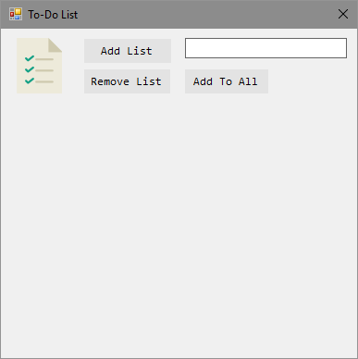

1. To add a new list, click the “Add List” button. To add two lists, click the button twice

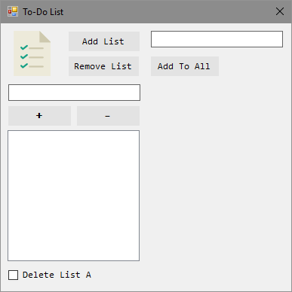

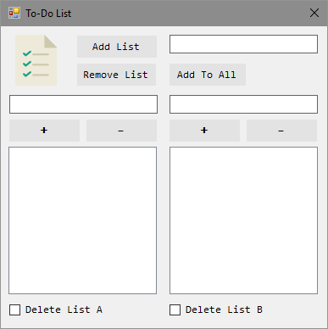

1. To delete a list, check the Delete List checkbox at the bottom of the list and then click the Remove List button

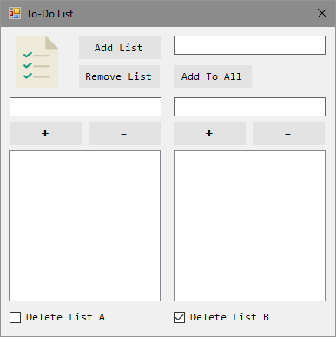



1. To add a task to a list, input the task in the textbox for the list and then click on the “+” button for that list

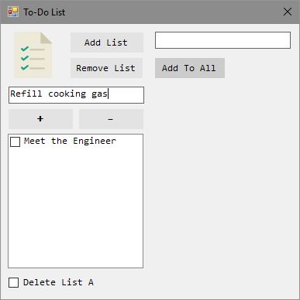

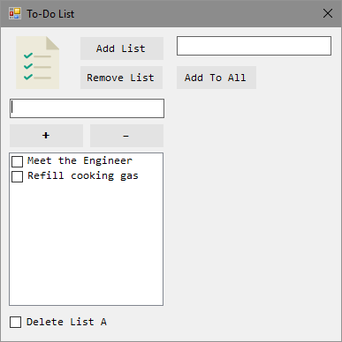

1. To remove a task from the list, select the task in the list and click the “-” button for that list

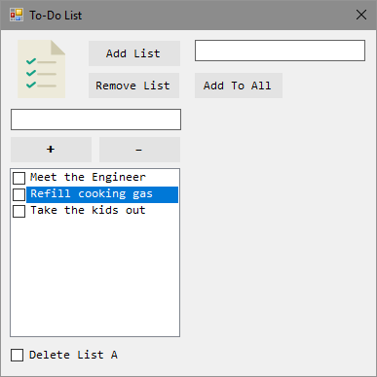

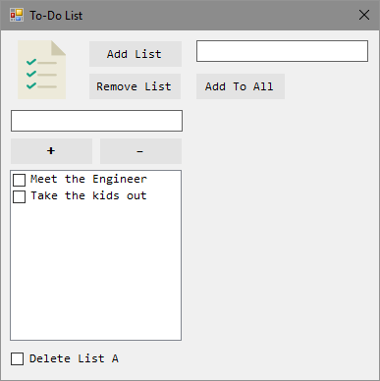

1. To mark a task as completed, check the checkbox for that particular task

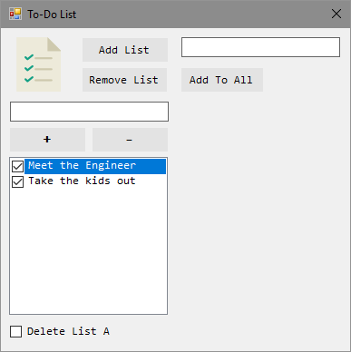

1. To add a task to all the existing lists, input the task into the textbox for Add To All and click the button

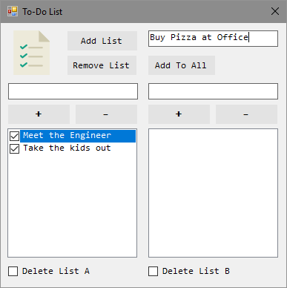

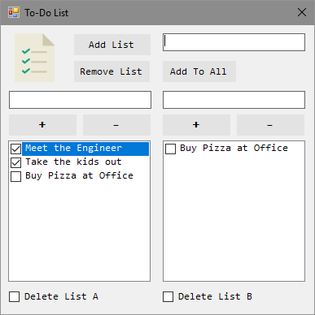

1. To clear the content of all active lists, click on the “clear” button

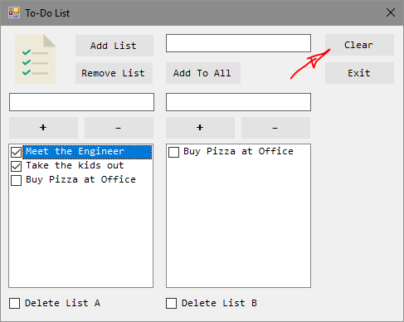

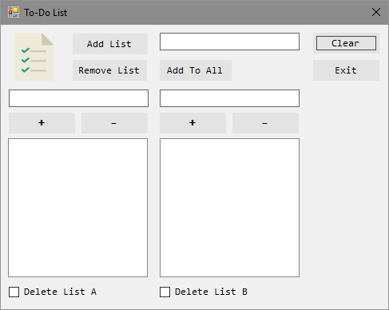

1. To exit the application, click the Exit button